Oceania-PAC-Melanesia-Solomon Is-New Georgia Is-Nguzu nguzu-Canoe figurehead-19th c

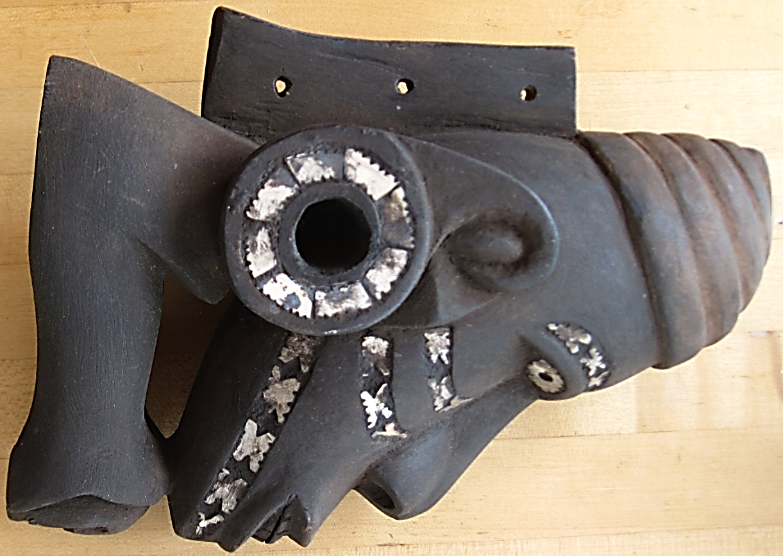 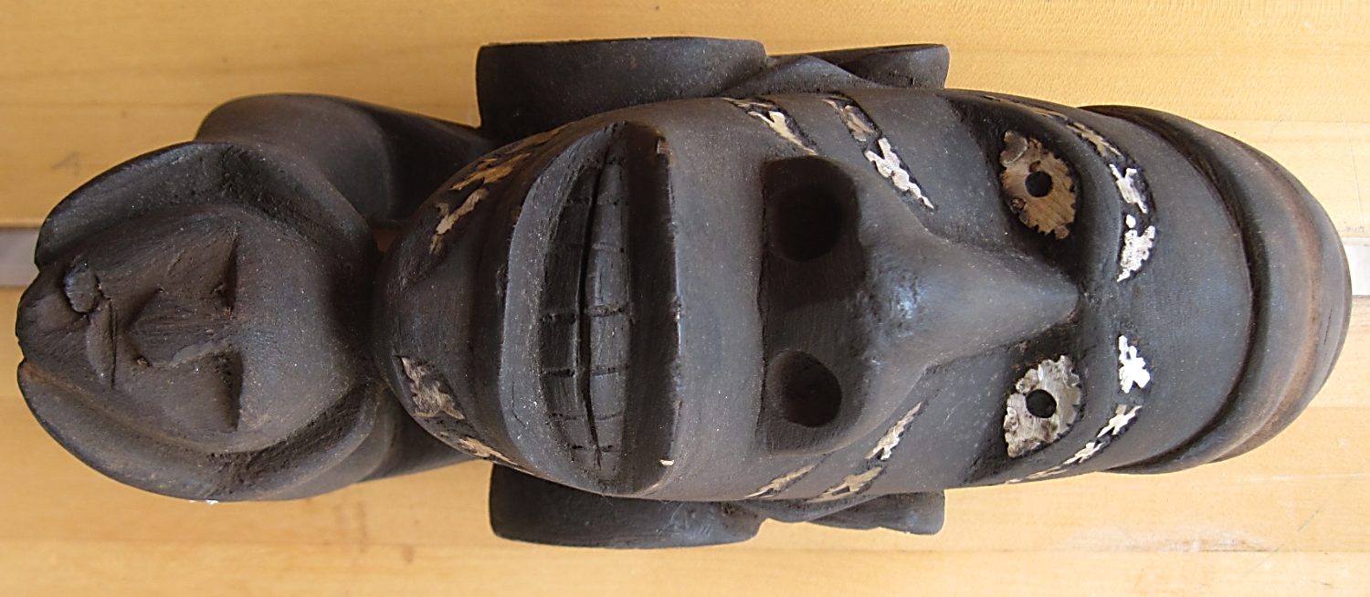 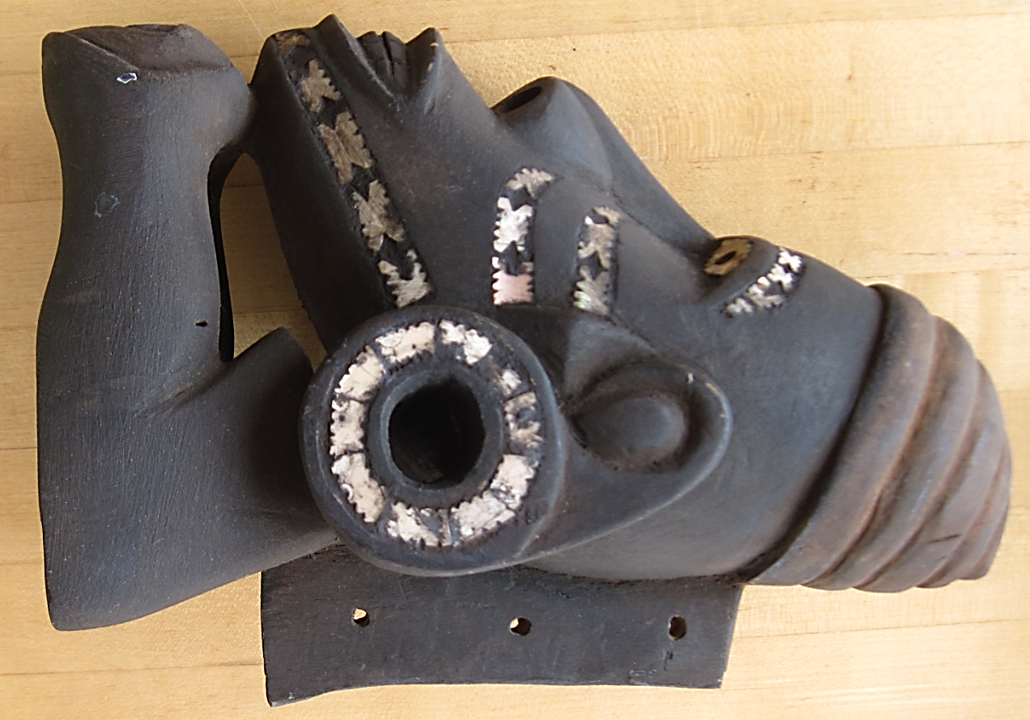

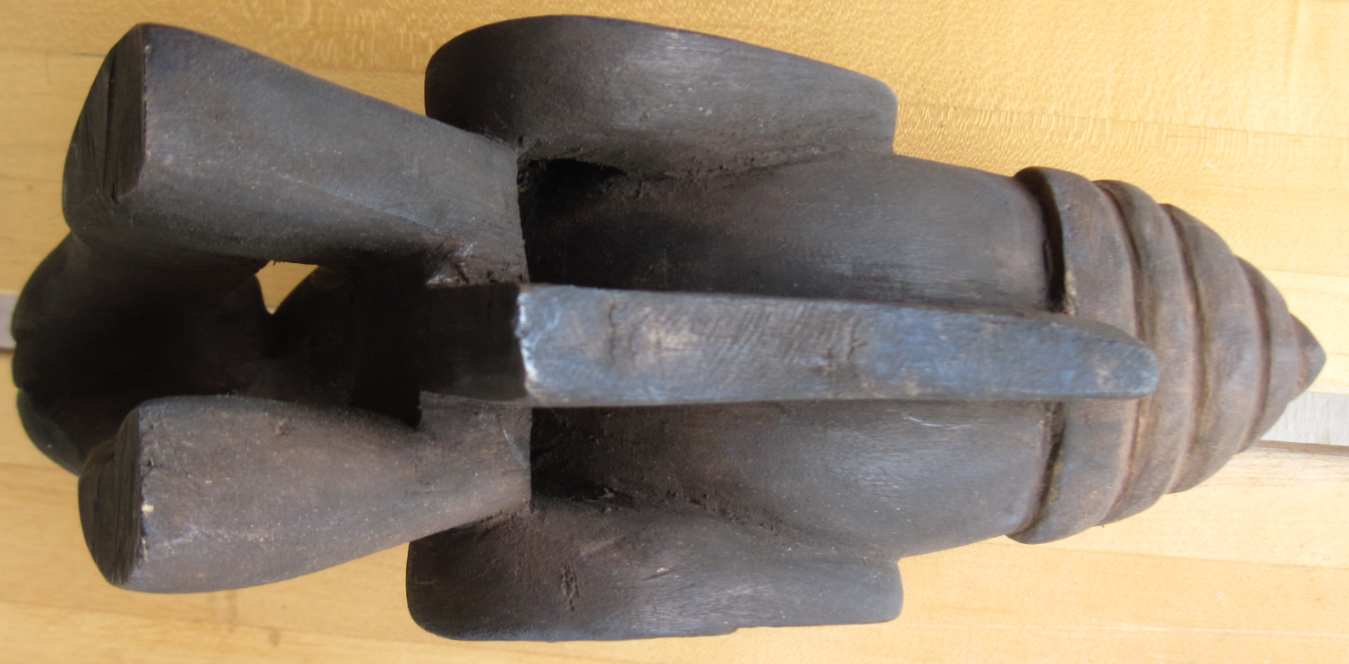

Figs. 1-4. Melanesia-Solomon Islands-[New Georgia Island-Nguzu nguzu-*Toto ishu*-Canoe figurehead of *Késoko*](https://www.artgallery.nsw.gov.au/collection/works/?origin_id=solomon-islands.new-georgia-island)-wood, nautilus shell, black dye-early 19th c. *Késoko,* who is obviously human in appearance, has a distinctive, mandibular prognathous jaw. Probably the original Késoko was once a prominent head-hunter. He wears a turban-style cap. Nautilus shell inlays indicate war paint on his cheeks and chin. The round plugs inserted into his elongated earlobes are also decorated with nautilus shell inlays.

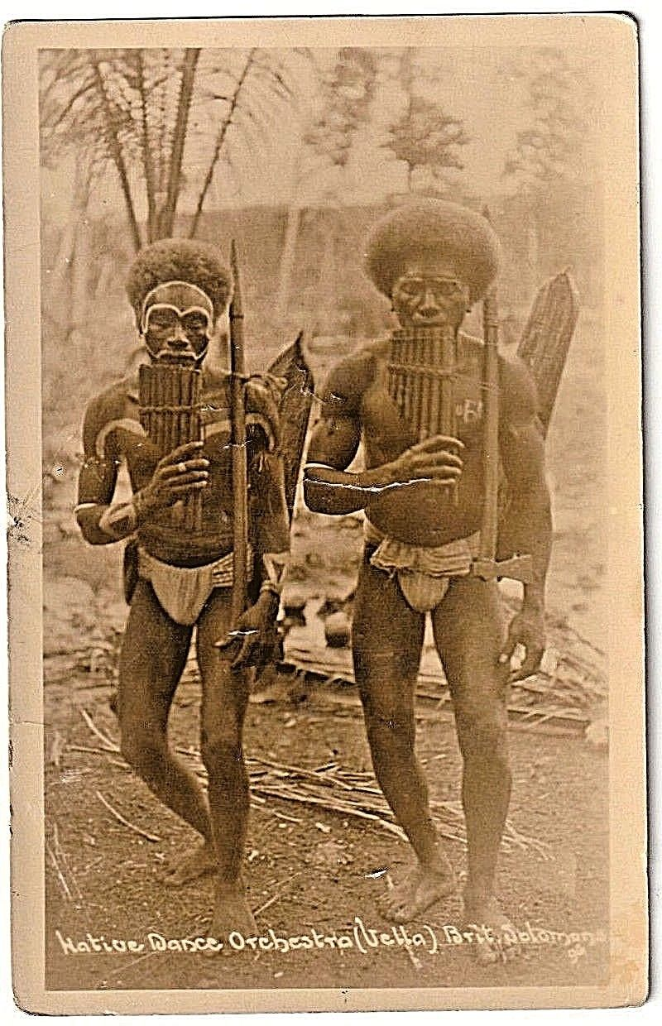

Two head-hunting warriors carrying their shields and battle axes. They play their flutes which is supposed to immobilize the enemy before their heads are taken in battle. They display white war paint on their faces which is similar to the designs made by the nautilus shell inlays on the face of *Késoko* on *Nguzu nguzus* or *Toto ishus.* The photographer was oblivious to the rôle the flutes played in Solomon Islanders’ lives, thinking they were mere musical instruments and not battle instruments. From a photograph taken in Malaita, Vella Lavella, Guadacanal printed on a post card printed in Great Britain c 1910..

**Case no.: Oceania**

**Accession Number:**

**Formal Label:** Melanesia-Solomon Islands-[New Georgia Island-Nguzu nguzu-*Toto ishu*-Canoe figurehead of *Késoko*](https://www.artgallery.nsw.gov.au/collection/works/?origin_id=solomon-islands.new-georgia-island)-wood, nautilus shell, black dye-early 19th c

**Display Description:**

War canoes or *tomokos* in the western Solomon Islands were essential to transportation, fishing, warfare and head-hunting. *Tomokos* were also an essential symbolic aspect of island identity with their tall curving prows decorated with inlaid nautilus shell and cowries. Inserted into each canoe prow is a *toto ishu* or *nguzu nguzu* with acarved figurehead of *Késoko,* the supernatural protector of the canoe. The *toto ishu* or *nguzu nguzu* was attached at the waterline of the prow, and although it appeared diminutive when seen in this position on a massive *tomoko*, it was, perhaps, the most important element of the *tomoko*.

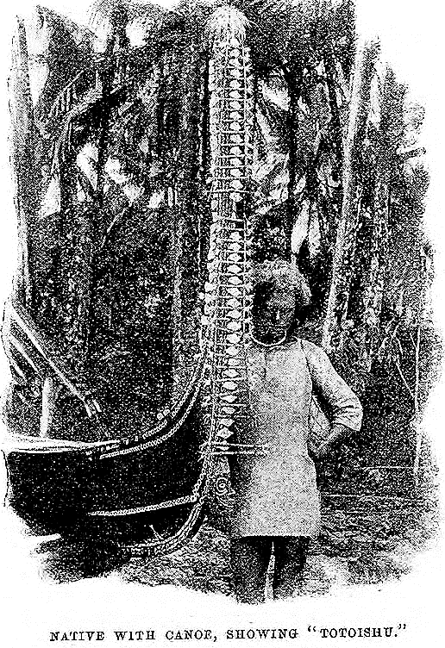

Solomon Islander showing the size and position of the *toto ishu* or *nguzu nguzu* inserted into the prow of a war canoe or *tomoko*. (Somerville and Hocart. 1897).

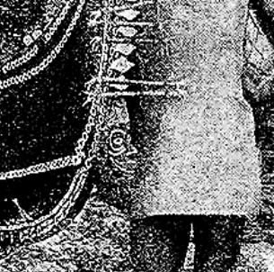

Detail of a Solomon Islander showing the size and position of the *toto ishu* or *nguzu nguzu* inserted into the pro of a *tomoko*. (Somerville and Hocart. 1897).

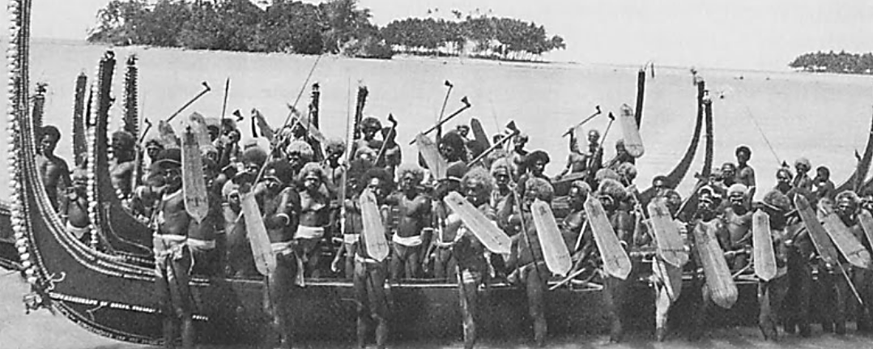

War canoes or *tomokos* on Vella Lavella Island, c 1922, with a *toto ishu* or *nguzu nguzu* inserted in the prow of the canoe in the foreground at the water-line in the lower left. The faces of the warriors are painted with designs similar to the nautilus shell inlays in the head of *Késoko*. The men are armed with battle axes and basketry shields. From a photo by E. A. Salisbury in Craig and Beran, 2005, p. 242, fig. 8.21.

As the *toto ishu* or *nguzu nguzu* dipped into the water, *Késoko* acted as a supernatural protector, ensuring safe passage and a successful head-hunting expedition. Lieutenant Boyle Sommeville, a British naval officer described this in 1893: “Low down on the head and shoulders of a *Totoishu* is suspended [the carved image of *Késoko*]; it is so placed as to dip into the water in front of the canoe. The function of the *Totoishu* is to keep off the [other] *Késoko*, or water fiends, which might otherwise cause the winds and waves to overset the canoe, so that they might fall and devour its crew” (Somerville 1903). In order to be so potent in their protection of the crew, the *toto ishu* or *nguzu nguzu* had an ambivalent potency according to a Solomon Islander, Geoffrey Beti, writing in the 1970’s: “The *nguzu nguzu* [*toto ishu*] in front of a *tomoko* was an image of *Késoko* as he kept a constant watch without ever closing his eyes. In this way *Késoko* was believed to have functioned as a pilot of the great *tomoko* through unknown waters, passages, reefs, and, of course, to look out for enemies to see that none escaped” (Beti 1972). The images *Késoko* are uniformly designed busts depicted with large heads wearing circular ear ornaments adorned with nautilus shell indicating the prominence of this symbolic protector. They were and painted black with war paint markings to accentuate their fearsomeness in battle. Extended, diminutive hands hold a decapitated head that was indicative of the goal of the head-hunting expedition. The protruding jaws of the *Késoko* suggest the determination of this spirit to assure a successful war party and to protect the warriors from other dangerous sea spirits.

**LC Classification:**

**Date or Time Horizon:**

**Geographical Area:**

**Map:**

**GPS coordinates:**

**Cultural Affiliation:**

**Media:**

**Dimensions:**

**Weight:**

**Condition:**

**Provenance:**

**Discussion:**

**References:**

Chick, John, and Sue Chick, eds. 1978. *Grass Roots Art of the Solomons: Images and Islands.* Sydney and New York: Pacific Publications.

Craig, B. and Beran, H. eds. 2005. Shields of Melanesia. Honolulu : University of Hawai'i Press, in association with Oceanic Art Society.

Jones, Mark. 1979. *The art of the medal.* London, pp. 91–96.  
  
Kjellgren, Eric. 2007. Oceania: *Art of the Pacific Islands in the Metropolitan Museum of Art*. New York and New Haven: The Metropolitan Museum of Art, no. 100, pp. 170–171.  
  
Kjellgren, Eric. 2014. *How to Read Oceanic Art. How to Read 3*. New York: The Metropolitan Museum of Art, p. 82.

Somerville, B., and A. M. Hocart. 1897. "Ethnographical Notes: New Georgia, Solomon Islands." *Journal of the Royal Anthropological Institute,*vol. XXVI, pp. 357-412. pp. 362, 369, 371, 378.

Appendix:

